Geometry: Unit 5, Lesson 9
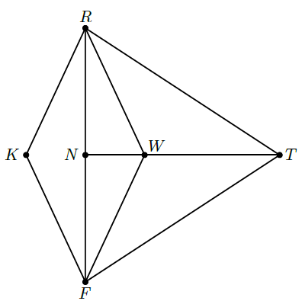
- Quadrilateral $RTFK$ is shown, where $RN=4.25$, $RT=7.1$, $NT=6.5$, $FR=8.5$, $RW=4$, $m∠TWR=115°$, $m∠TFW=26°$, $m∠WRN=33°$, and $m∠RTW=39°$. Given $∆RWF≅∆RKF$ and $∆RWN≅∆FWN$, what is the length of $FW$?

$$4$$
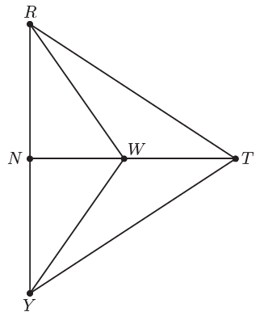

- Triangle $RTY$ is shown where $\overline{TN}$ is a perpendicular bisector of $\overline{RY}$ and point $W$ is a point on $\overline{NT}$. How many different triangles are in triangle $RTY$?

$$8$$

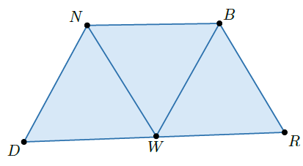
- Quadrilateral $BRDN$ is shown. Point $W$ lies on $\overline{DR}$. How many different triangles are in quadrilateral $BRDN$ ?

$$3$$

